This lesson will introduce you to the Word window. You use this window to interact with Word. To begin this lesson, open Microsoft Word 2007. The Microsoft Word window appears and your screen looks similar to the one shown here.

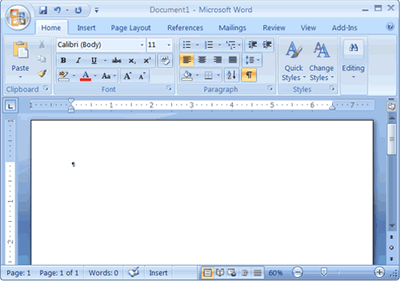

**The Microsoft Office Button**

Office ButtonIn the upper-left corner of the Word 2007 window is the Microsoft Office button. When you click the button, a menu appears. You can use the menu to create a new file, open an existing file, save a file, and perform many other tasks.

**The Quick Access Toolbar**

Quick Access ToolbarNext to the Microsoft Office button is the Quick Access toolbar. The Quick Access toolbar provides you with access to commands you frequently use. By default Save, Undo, and Redo appear on the Quick Access toolbar. You can use Save to save your file, Undo to rollback an action you have taken, and Redo to reapply an action you have rolled back.

**Title BarThe Title Bar**

Next to the Quick Access toolbar is the Title bar. The Title bar displays the title of the document on which you are currently working. Word names the first new document you open Document1. As you open additional new documents, Word names them sequentially. When you save your document, you assign the document a new name.

**The Ribbon**

You use commands to tell Microsoft Word what to do. In Microsoft Word 2007, you use the Ribbon to issue commands. The Ribbon is located near the top of the screen, below the Quick Access toolbar. At the top of the Ribbon are several tabs; clicking a tab displays several related command groups. Within each group are related command buttons. You click buttons to issue commands or to access menus and dialog boxes. You may also find a dialog box launcher in the bottom-right corner of a group. Clicking the dialog box launcher gives you access to additional commands via a dialog box.

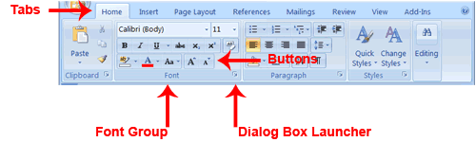

**The Ruler**

The ruler is found below the Ribbon.

The Ruler

You can use the ruler to change the format of your document quickly. If your ruler is not visible, follow the steps listed here:

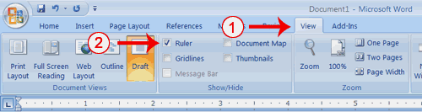

**EXERCISE 1**

1. Click the View tab to choose it.
2. Click the check box next to Ruler in the Show/Hide group. The ruler appears below the Ribbon.

**The Status Bar**

The Status bar appears at the very bottom of your window and provides such information as the current page and the number of words in your document. You can change what displays on the Status bar by right-clicking on the Status bar and selecting the options you want from the Customize Status Bar menu. You click a menu item to select it. You click it again to deselect it. A check mark next to an item means it is selected.

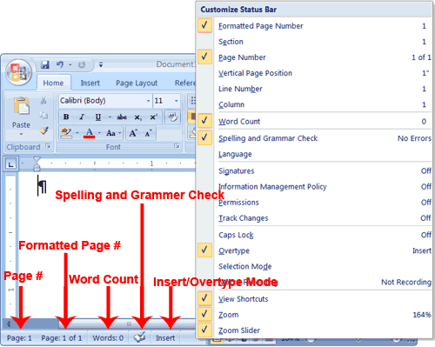

**Understanding Document Views**

In Word 2007, you can display your document in one of five views: Draft, Web Layout, Print Layout, Full Screen Reading, or Online Layout.

*Draft View*

Draft view is the most frequently used view. You use Draft view to quickly edit your document.

*Web Layout*

Web Layout view enables you to see your document as it would appear in a browser such as Internet Explorer.

*Print Layout*

The Print Layout view shows the document as it will look when it is printed.

*Reading Layout*

Reading Layout view formats your screen to make reading your document more comfortable.

*Outline View*

Outline view displays the document in outline form. You can display headings without the text. If you move a heading, the accompanying text moves with it.

You should use Draft view for these lessons. Before moving ahead, make sure you are in Draft view:

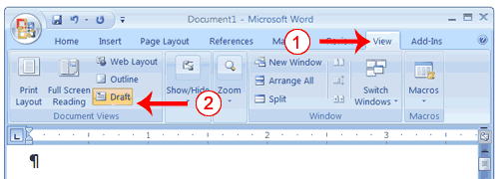

**EXERCISE 2**

1. Click the View tab.
2. Click Draft in the Document Views group. When the Draft option is selected it appears in a contrasting color.

**Understanding Nonprinting Characters**

Certain characters, called nonprinting characters, do not print and will not appear in your printed document but do affect your document layout. You can elect to see these characters on the screen as you type or you can elect to have them remain invisible. For these lessons, opt to see them onscreen. This table describes most of them:

|  |  |
| --- | --- |
| **Character** | **Denotes** |
| Denotes a tab� | A tab |
| . | A space |
| ¶ | The end of a paragraph |
| Denotes Hidden Text | Hidden text |

To view nonprinting characters:

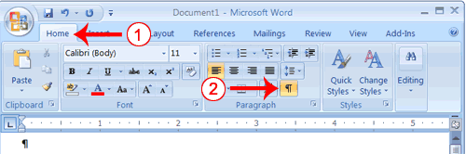

**EXERCISE 3**

1. Choose the Home tab.
2. Click the Show/Hide button Show Hide Icon in the Paragraph group. The Show/Hide button appears in a contrasting color, when it is selected.

**EXERCISE 5 - Placing the Insert/Overtype button on the Status bar**

1. Right-click the Status bar. The Customize Status Bar menu appears.
2. Click Overtype. The Insert/Overtype button appears on the Status bar.
3. If the word Insert appears on the Status bar, you are in Insert mode.
4. If the word Overtype appears on the Status bar, click the word Overtype and it will change to Insert, thereby changing Word to Insert mode.

**EXERCISE 6 - Insert**

Make sure you are in Insert mode before proceeding. You are going to insert the word "blue" between the words "large" and "boat."

1. Place the cursor after the space between the words "large" and "boat."
2. Type the word **blue**.
3. Press the spacebar to add a space.
4. The sentence should now read:   
   "Joe has a large blue boat."

**EXERCISE 7 - Overtype**

You can type over the current text (replace the current text with new text) in the Overtype mode. Do the following to change to the Overtype mode.

* Click "Insert" on the Status bar. The word Insert changes to Overtype.

Change the word "blue" to "gray."

1. Place the cursor before the letter "b" in "blue."
2. Type the word **gray**.
3. The sentence should now read:   
   "Joe has a large gray boat."

**EXERCISE 8** - Type the following exactly as shown.

**Ribbon: Bold Italicize Underline these words. All three Regular**

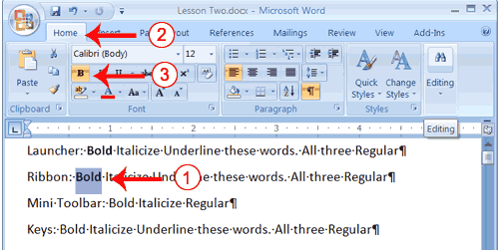

1. On the line that begins with "Ribbon," select the word "Bold."  Choose the Home tab.
2. Click the Bold button Bold Button in the Font group. You have bolded the word bold.  
   **Note:** To remove the bold, you can select the text and then click the Bold button Bold Button again.

**Repeat the same for underline and italic**

**EXERCISE 9 - Strikethrough, subscript and superscript**

The http://www.free-computer-tutorials.net/images/strikethrough.jpgbutton is used to strike through text. This can be very useful when you are editing a document and don’t want to loose your original thought.

http://www.free-computer-tutorials.net/images/Subscript.jpgand Superscriptare subscript and superscript. These are used for fractions I use these frequently when making recipe cards. The subscript and superscript will sometimes automatically change numbers into fractions while you are typing.

**EXERCISE 10 - Cut with the Ribbon**

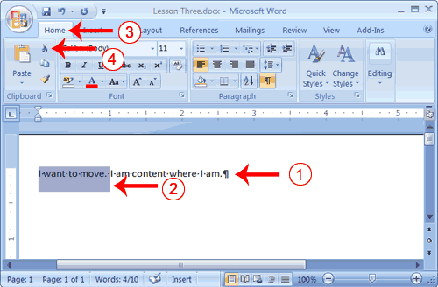

1. Type: **I want to move. I am content where I am.**
2. Select "I want to move.”
3. Click the Cut button Cut Button in the Clipboard group. Word cuts the text you selected and places it on the Clipboard. Your text should now read:   
   "I am content where I am."

**Paste with the Ribbon**

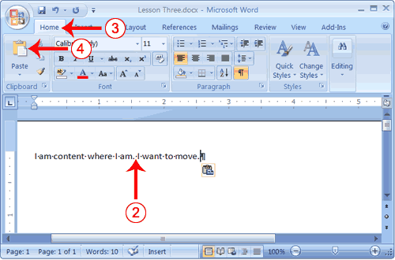

1. Place the cursor after the period in the sentence "I am content where I am."
2. Press the spacebar to leave a space.
3. Choose the Home tab.
4. Click the Paste button Paste Button in the Clipboard group. Word pastes the text on the Clipboard. Your text should now read:   
   "I am content where I am. I want to move."

**EXERCISE 11 - Use the Clipboard**

1. Place the cursor at the point at which you want to insert your text.
2. Choose the Home tab.
3. 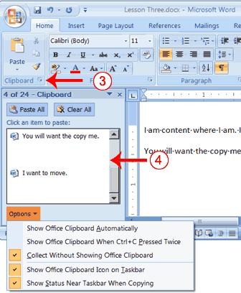Click the Clipboard dialog box launcher to open the Clipboard.
4. Click the item on the clipboard you want to insert into your document. Word pastes the Clipboard item into your document at the insertion point.

**EXERCISE 12 - Create AutoText**

1. 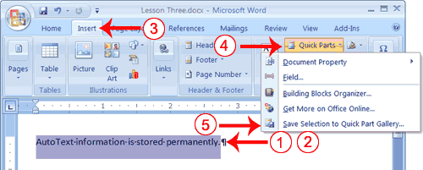Type the following:   
   **AutoText information is stored permanently.**
2. Select "AutoText information is stored permanently."
3. Choose the Insert tab.
4. Click Quick Parts in the Text group. A menu appears.
5. Click Save Selection to Quick Part Gallery. The Create New Building Block dialog box appears.

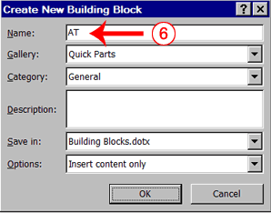

1. Microsoft Word suggests a name. Change the name by typing **AT** in the Name field.
2. Click OK. The dialog box closes.
3. Click anywhere in the text area to remove the highlighting.
4. Place the cursor between the period in the sentence you just typed and the paragraph marker (¶).
5. Press the spacebar to leave a blank space.
6. Type **AT**.
7. Press F3. Your text should now read:   
   "AutoText information is stored permanently. AutoText information is stored permanently."

**Note:** Whenever you need the text, simply type the name (AT) and then press F3.

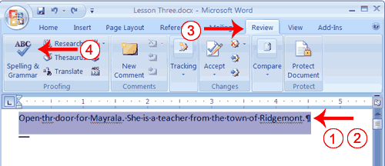**EXERCISE 13 - Use Spell Check**

1. Type the following exactly as shown. Include all errors.   
   **Open thr door for Mayrala. She is a teacher from the town of Ridgemont.**
2. Select: "Open thr door for Mayrala. She is a teacher from the town of Ridgemont."
3. Choose the Review tab.
4. Click the Spelling & Grammar button. The Spelling and Grammar dialog box appears.

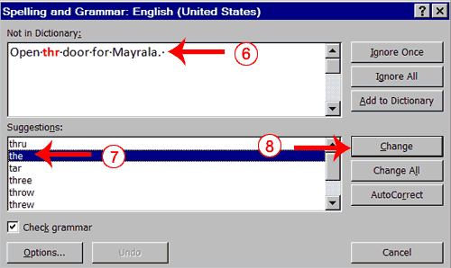

1. "The" is misspelled, so it is highlighted on the screen and noted in the Not in Dictionary box. Word suggests correct spellings. These suggestions are found in the Suggestions box.
2. Click "the" in the Suggestions box.
3. Click Change.   
   **Note:** If the word is misspelled in several places, click Change All to correct all misspellings.
4. The name "Mayrala" is not in the dictionary, but it is correct. Click Ignore Once to leave "Mayrala" in the document with its current spelling.  
   **Note:** If a word appears in several places in the document, click Ignore All so you are not prompted to correct the spelling for each occurrence.
5. "Ridgemont" is not found in the dictionary. If you frequently use a word not found in the dictionary, you might want to add that word to the dictionary by clicking the Add to Dictionary button. Word will then recognize the word the next time it appears. Click Add to Dictionary.
6. The following should appear on your screen: "Word finished checking the selection. Do you want to continue checking the remainder of the document?"
7. Click No. If you wanted Word to spell-check the entire document, you would have clicked Yes.

**Note:** You can also press F7 to initiate a spelling and grammar check. If you don't have anything selected, Word checks the entire document.

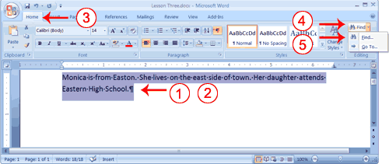.**EXERCISE 14 - Use Find with the Ribbon**

1. Type the following:   
   **Monica is from Easton. She lives on the east side of town. Her daughter attends Eastern High School.**
2. Select: "Monica is from Easton. She lives on the east side of town. Her daughter attends Eastern High School."
3. Choose the Home tab.
4. Click Find in the Editing group. A menu appears.
5. Click the Find option on the menu. The Find and Replace dialog box appears.

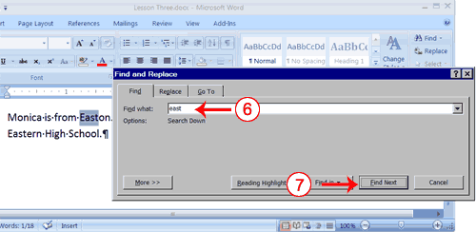

1. Type **east** in the Find What field.
2. Click Find Next. Note that the "East" in Easton is highlighted.
3. Click Find Next again. Note that "east" is highlighted.
4. Click Find Next again. Note that the "East" in Eastern is highlighted.
5. Click Find Next. The following message should appear: "Word has finished searching the selection. Do you want to search the remainder of the document?"
6. Click No.
7. Click Cancel.

**EXERCISE 15 - Add Space Before or After Paragraphs**

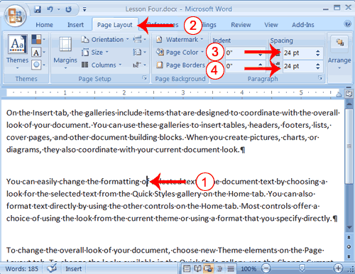

1. Place your cursor anywhere in the second paragraph of the sample text you created in Exercise 2.
2. Choose the Page Layout tab. The default spacing appears in the Spacing Before field.
3. Click the up arrow next to the Spacing Before field to increase the space before the paragraph.
4. Click the up arrow next to the Spacing After field to increase the amount of space after the paragraph.

**Note:** You can click the down arrows next to the Spacing Before and the Spacing After fields to decrease the amount of space before or after a paragraph. You can also type the amount of space you want to use directly into the fields. Space is measured in points. There are 72 points to an inch.

**EXERCISE 16 - Change Line Spacing**

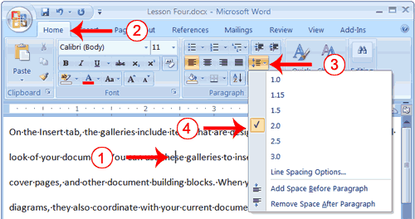

1. Place your cursor anywhere in the first paragraph of the sample text you created in Exercise 2.
2. Choose the Home tab.
3. Click the Line Spacing button http://www.baycongroup.com/word2007/images/04_LineSpaceButton.gif in the Paragraph group. A menu of options appears.
4. Click 2.0 to double-space the first paragraph.

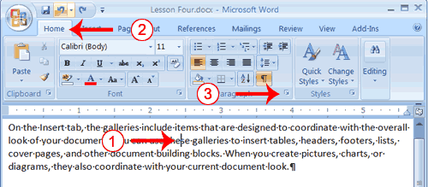**EXERCISE 17 - Create a First-line Indent**

1. Place your cursor anywhere within the first paragraph of the sample text you created in Exercise 2.
2. Choose the Home tab.
3. 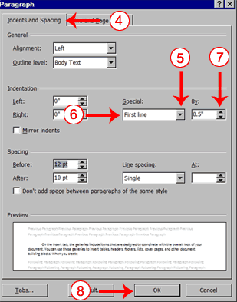In the Paragraphs group, click the launcher. The Paragraph dialog box appears.
4. Choose the Indents and Spacing tab.
5. Click to open the drop-down menu on the Special field.
6. Click First Line.
7. Enter 0.5" in the By field.
8. Click OK. The first line of your paragraph is now indented half an inch.

**EXERCISE 18 - Indent Paragraphs**

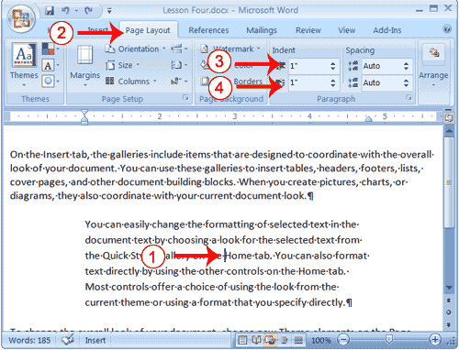

1. Place your cursor anywhere in the second paragraph of the sample text you created in Exercise 2.
2. Choose the Page Layout tab.
3. Type **1"** in the Indent Left field or use the up or down arrows to set the field value to 1".
4. Type **1"** in the Indent Right field or use the up or down arrows to set the field value to 1". Your paragraph is now indented one inch from both the left and right margins, as in the example.

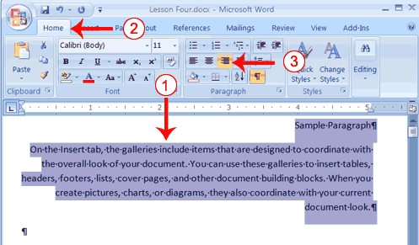**EXERCISE 19 - Create the Paragraphs**

1. Type Sample Paragraph.
2. Press Enter.
3. Type =rand(1) to create a paragraph.
4. Press Enter.

**Right-align**

1. Select the paragraphs you created.
2. Choose the Home tab.
3. Click the Align-right button Align-right Button in the Paragraph group. Word right-aligns your paragraphs.

**EXERCISE 20 - Create a Hanging Indent**

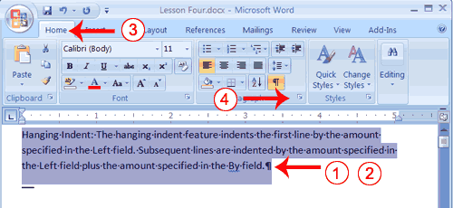

1. Type the following:   
   Hanging Indent: The hanging indent feature indents the first line by the amount specified in the Left field. Subsequent lines are indented by the amount specified in the Left field plus the amount specified in the By field.
2. Select the paragraph you just typed.
3. Choose the Home tab.
4. Click the launcher in the Paragraph group. The Paragraph dialog box appears.
5. Choose the Indents and Spacing tab.
6. In the Special field, click to open the pull-down menu.
7. Click Hanging.
8. In the By box, type **2"**.
9. Click OK.
10. Place the cursor after the colon following "Hanging Indent."
11. Press the Tab key. Notice that the indentation changes.

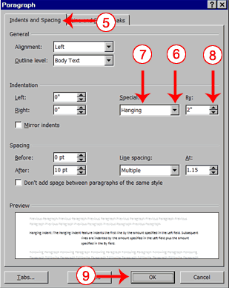

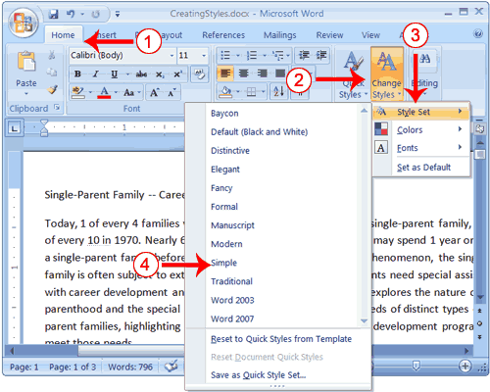

**EXERCISE 21 - Choose a Style Set**

1. Choose the Home tab.
2. Click Change Styles in the Styles group. A menu appears.
3. Click Style Set. A menu appears. You can choose from any of the styles listed on the menu.
4. Click Simple. Word 2007 reformats all of the paragraphs into the Simple style by applying the Normal format to each paragraph.

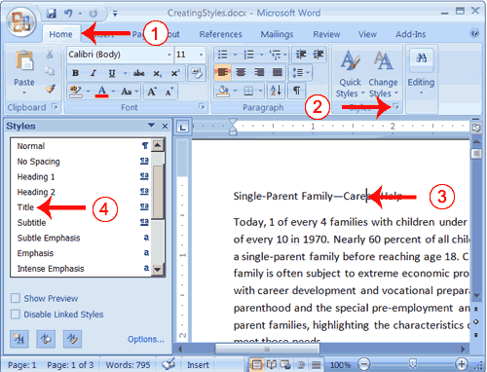**EXERCISE 22 - Apply the Title Style**

1. Choose the Home tab.
2. Click the launcher in the Styles Group. The Styles pane appears. You can drag it to the side of the Word window to dock it. To close the Styles pane, click the Close button http://www.baycongroup.com/word2007/images/04_Closebutton.gif in the upper right corner of the pane .
3. Click anywhere in the paragraph "Single-Parent Family—Career Help."
4. Click Title in the Styles pane. Word 2007 applies the Title style to the paragraph.

Headings and subheadings mark major topics within your document. With Word 2007, you can easily format the headings and subheadings in your document.

**Apply Headings**

1. Click anywhere in the paragraph "The Nature of Single Parenthood."
2. In the Style box, click Heading 1. Word reformats the paragraph.
3. Repeat steps 1 and 2 in the following paragraphs:

* Types of Single Parents
* Career Development Needs of Single Parents
* Career Development Programs

**Apply Subheadings**

1. Click anywhere in the paragraph "Displaced Homemakers"
2. In the Style box, click Heading 2. Word reformats the paragraph.
3. Repeat steps 1 and 2 for the following paragraphs:

* Displaced Homemakers
* Adolescent Mothers
* 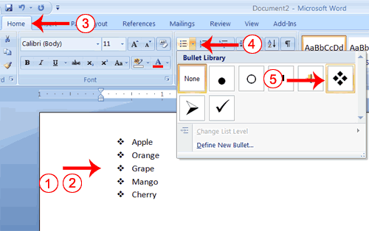Single Fathers
* High School Dropout Prevention
* Established Education Sites

**EXERCISE 23 - Bullets and Numbering**

1. Type the following list as shown:  
   **Apple**   
   **Orange**   
   **Grape**   
   **Mango**   
   **Cherry**
2. Select the words you just typed.
3. Choose the Home tab.
4. In the Paragraph group, click the down arrow next to the Bullets button Bullets button. The Bullet Library appears.
5. Click to select the type of bullet you want to use. Word adds bullets to your list.

**EXERCISE 24 - Sorting a list**

1. Word® 2007 has a number of options for sorting lists. This can be lines of text, paragraphs, numbers or actual lists of data.
2. Highlight the items to be sorted
3. From the home tab select the sort button
4. Then various options can be picked, sorting both ascending and descending.
5. You can also sort by more than one option.

**• Once you have selected the options you require click ok.**

**EXERCISE 25 - Set the Orientation**

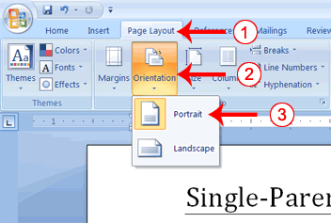

1. Choose the Page Layout tab.
2. Click Orientation in the Page Setup group. A menu appears.
3. Click Portrait. Word sets your page orientation to Portrait.

**EXERCISE 26 - Set the Page Size**

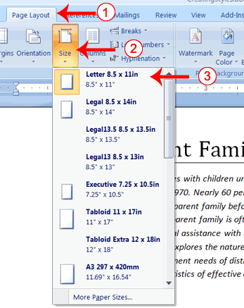

1. Choose the Page Layout tab.
2. Click Size in the Page Setup group. A menu appears.
3. Click Letter 8.5 x 11in. Word sets your page size.

**EXERCISE 27 - Set the Margins**

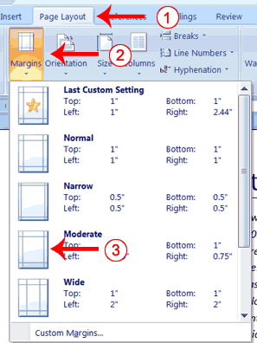

1. Choose the Page Layout tab.
2. Click Margins in the Page Setup group. A menu appears.
3. Click Moderate. Word sets your margins to the Moderate settings.

**EXERCISE 28**

**Add Page Numbers**

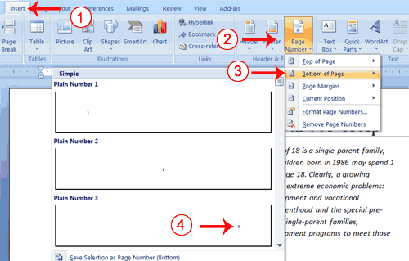

1. Choose the Insert tab.
2. Click the Page Number button in the Header & Footer group. A menu appears.
3. Click Bottom of Page.
4. Click the right-side option.

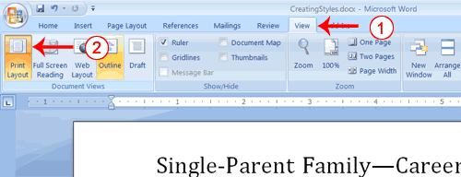**EXERCISE 29 - Change to Print View**

1. Choose the View tab.
2. Click Print Layout in the Document Views group. Your document changes to the Print Layout view.

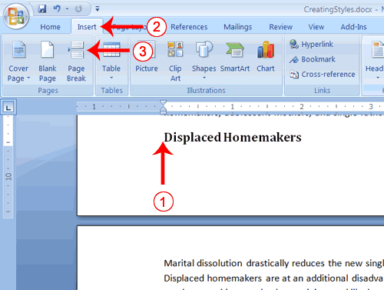**EXERCISE 30 - Insert Page Breaks**

1. Place your cursor before the D in "Displaced Homemakers"
2. Choose the Insert tab.
3. Click Page Break. Word places a page break in your document.

To delete a page break, you select the page break and then press the Delete key.

**EXERCISE 31**

**Print Preview**

1. Click the Microsoft Office button. A menu appears.
2. Highlight the Print option. The Preview and Print the Document menu appears.
3. Click Print Preview. The Preview window appears, with your document in the window.
4. Click One Page to view one page at a time. Click Two Pages to view two pages at a time.
5. To view your document in normal size, click 100%.
6. Click the Zoom Button. The Zoom dialog box appears.
7. Select an option and then click OK. Perform this task for each option and note the results.

**Lab Test**

1. Add open command to the quick access toolbar.
2. Disable spell checker.
3. Enter three paragraphs, give headings to three of them and set the following properties
   1. Line spacing – 2
   2. Justify the text.
   3. Indent the first paragraph.
   4. Sort the paragraphs alphabetically.
   5. Show paragraph marks.
   6. Increase the space between the paragraphs.
   7. Replace word “the” with “a”
   8. Insert page no. in the center.
4. View the document in draft view
5. Change the orientation to landscape.
6. Change the page size to “Legal”
7. Use quick part in your document